|  |  |
| --- | --- |
| The looming storm  The Data Behind Tornado Alley | Abstract  The world is an unpredictable place especially in the field of weather. The concept of tornado alley has been noted for decades and typically lies in the heart of the United States. Upon further data analysis, will this remain the case? Will the concept of Tornado Alley still hold up?  Brian J Cignetti, Forrest Fallon  IST 718 – Big Data Analytics |

Table of Contents

Introduction 2

Data Cleaning and Preparation 3

Modeling and Visualizations 5

Visualizations 5

Preliminary Visualizations 5

Choropleths 7

Models 9

Linear Model 9

LTSM Model 9

Forecast Model 9

Cluster Model 10

Analysis of Results 12

Visualizations 12

Models 12

Linear Model 12

LTSM Model 12

Forecast Model 12

Cluster Model 13

Conclusions 13

Appendix A 14

# Introduction

Tornado Alley was a term created in the 1950’s by weather scientists trying to shed light on the fact that some states within the US are in more danger when it comes to tornadic activity. While at the time this was a great marketing tactic used to spread awareness to those within these states, we felt as though it was worth another look to see how the area within Tornado Alley might have shifted in the 70 years since.

With that question in mind, we set out to utilize statistical measurements and forecasting models learned throughout the Data Science program in order to properly analyze and visualize our findings. We hope that this project can shed some light on the level of risk each state in the U.S. has when it comes to specifically tornados, as well as educate people about the facts behind these cyclonic disasters.

# Data Cleaning and Preparation

Data was pulled directly from the National Oceanic and Atmospheric Administration, from a directory of their files (<https://www.ncei.noaa.gov/pub/data/swdi/stormevents/csvfiles/>). From this corpus of files there were reports of all natural disasters that have been recorded from the year1950-the month of pull 2022. In which there were 72 files pulled and put into a folder. Three packages were used in the process of merging the data into a usable format. Pandas was the data frame, os allowed access to the necessary folders, and glob allowed for the merging of the mass number of files. Using this package, the csv files were read through a loop, and appended to each other to create one data frame.

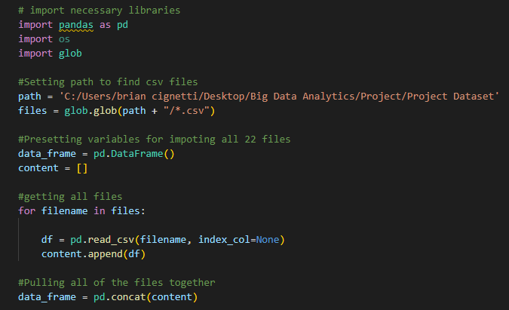

Now that all of the csv files were together some last-minute cleanups were implemented to make the data easier to use going forward, as well as adjusting the frame to only contain pertinent data. Because the initial data source contained values from every recorded natural disaster including hurricanes, floods, and snowstorms, a simple slice of the data was taken only leaving the data labeled as “tornado” data. Finally, because the data set contained many unnecessary values, only certain values were selected to continue being used shown in the block of code following this paragraph.

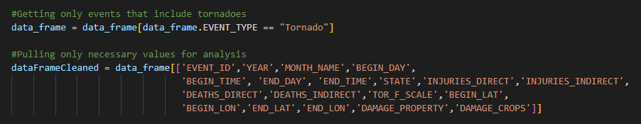

Finishing the filtering of our data set there was a blatant disregard from the NOAA to put the property damage in a usable format, so this needed to be addressed. To tackle this issue, each value needed to be converted from a character representation value to a numeric value. Not wanting to be bothered going through and changing 70,000 tornado results, a for loop was created to go through each abbreviation and convert to a numeric value accordingly. With that the final step in the data preparation was creating some columns for ease of access later in the analysis. This resulted in the creation of a totals column for injuries, deaths, and damage.

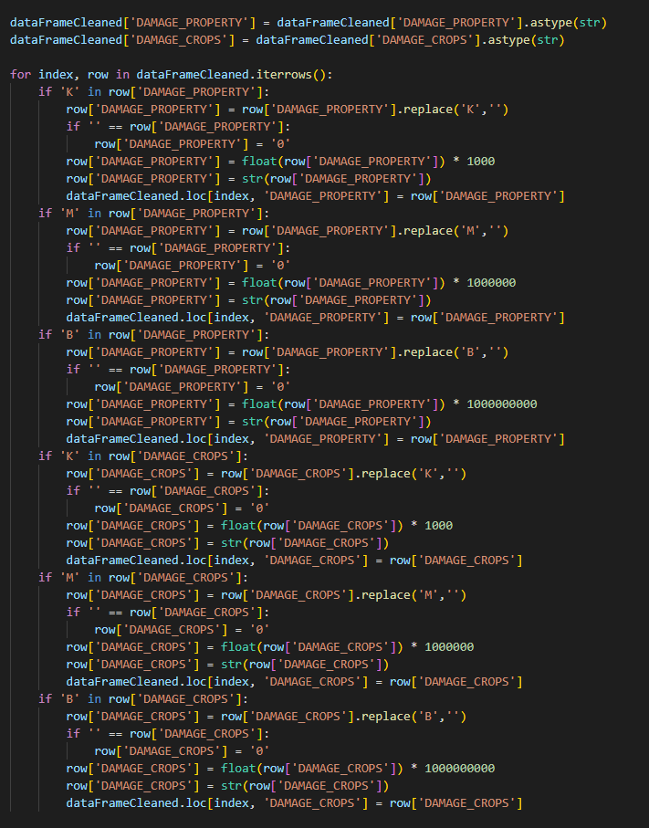

With that the data was appropriately merged and formatted into a usable format for the analysis. There was additional cleaning required for certain visual techniques and models however this rendition of the data set was exported to a csv for further use.

# Modeling and Visualizations

Although a majority of the data science process is getting data into a usable format, the meat of the project that gives value is the models and visualizations. During this section we intended to give a dynamic look of tornado activity and create some models showing the current landscape and future inclinations of tornadoes.

## Visualizations

### Preliminary Visualizations

When it comes to analyzing the concept of Tornado Alley, the biggest visualization that can tell the story is looking at where all of the tornadoes occur. This started with an initial look at trends of all tornado observations recorded in the NOAA data. To accomplish this the initial data frame was grouped into a format by year. This allowed an easy creation of a line graph that showed how many tornadoes occur each year using the Plotly package in python. Just like many of the visualizations created during the analysis this one has an interactive html document that allows a more in depth look of the statistics.

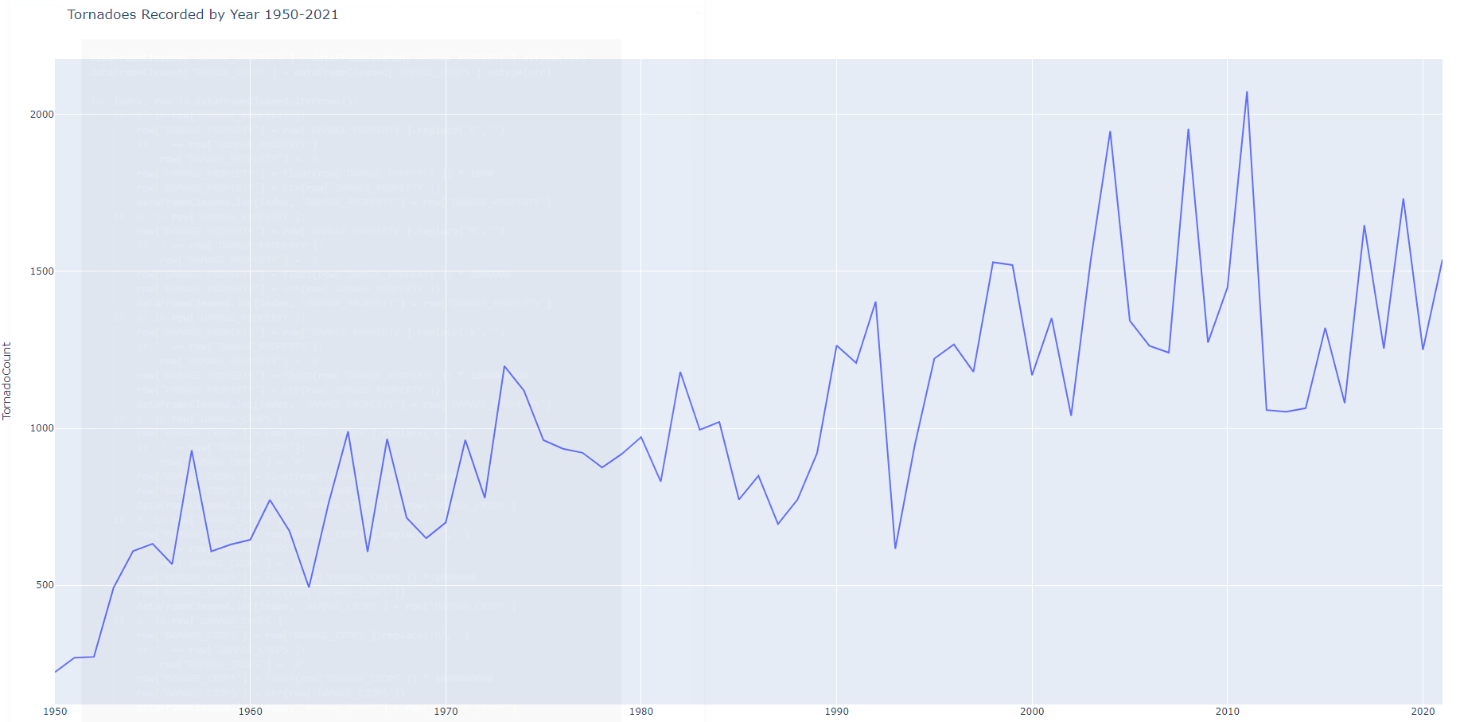

Continuing to look further in depth, an analysis was conducted looking at each of the states to get a general feel of where all of the tornadoes are occurring. To perform this analysis each of counts needed to be grouped by state. Just like sifting by year the data frame was grouped by state to get a data frame of all of the states by year. This data was then plugged into two visualization types. One was an interactive line chart like the full results that allows filtering through the html file and a tree plot that depicts the number of tornadoes per state by size.

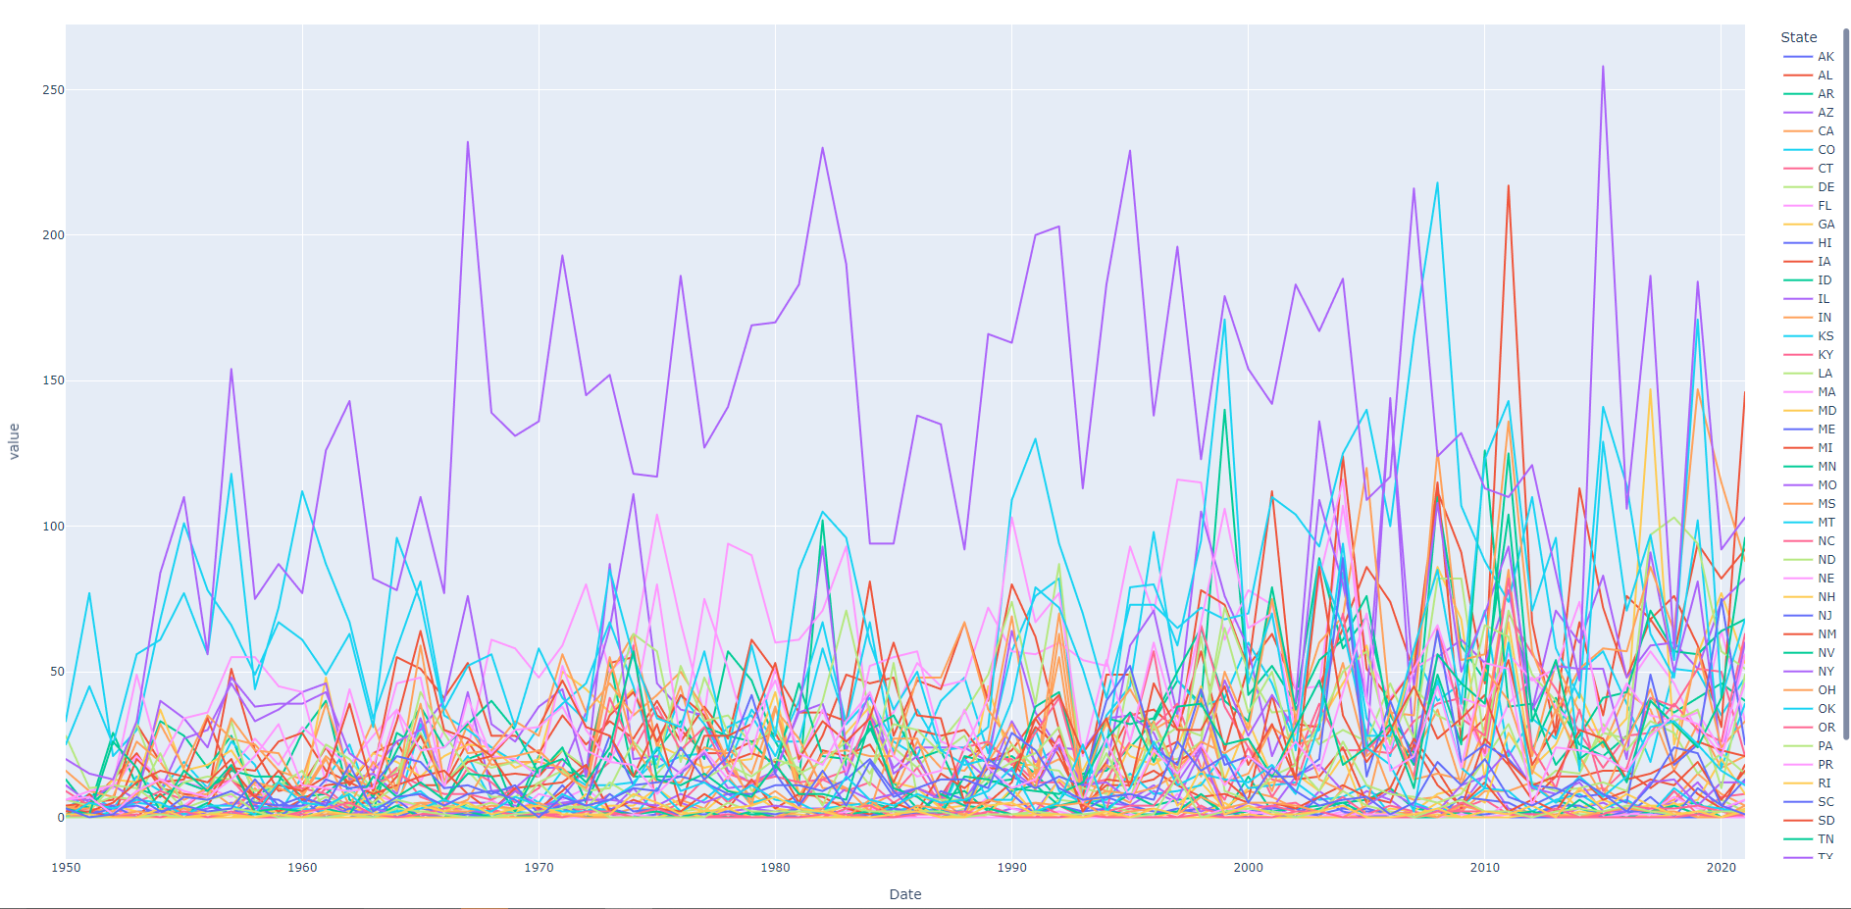

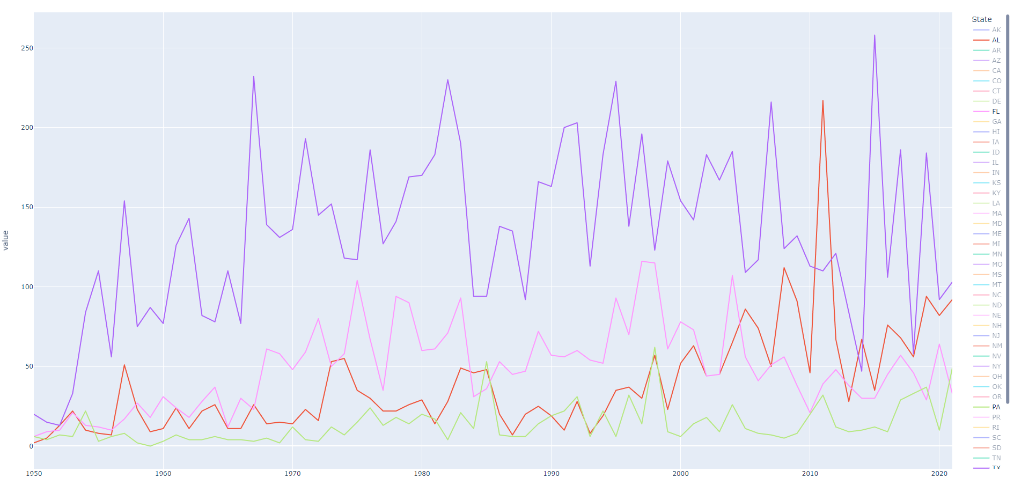

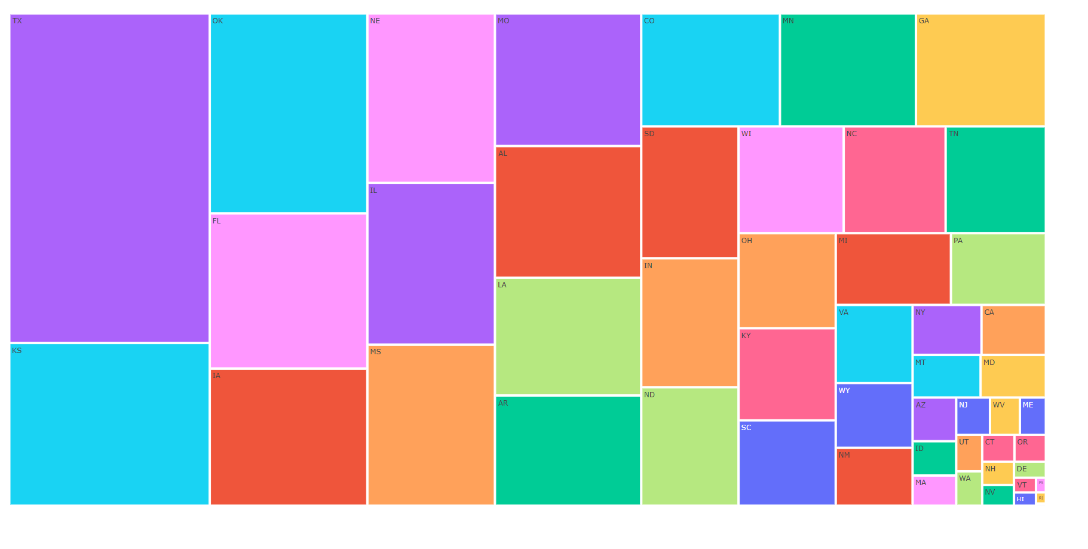

### Choropleths

After some of the simple visualizations, we wanted to create a couple of visualizations that truly put the data into perspective. Many sources use maps to show this type of data and we chose to resemble the data in the same manner. Using the data frames from the previous visualizations, the Plotly express package was called. Using this package, a choropleth was called using the United States map as the scope coloring by counts. From this one choropleth was created that resembles all of the tornadoes recorded in every state throughout 72 years, another was created that shows tornadoes by year with an interactive timeline. Each visualization is interactive showing counts thanks to the Plotly python package.

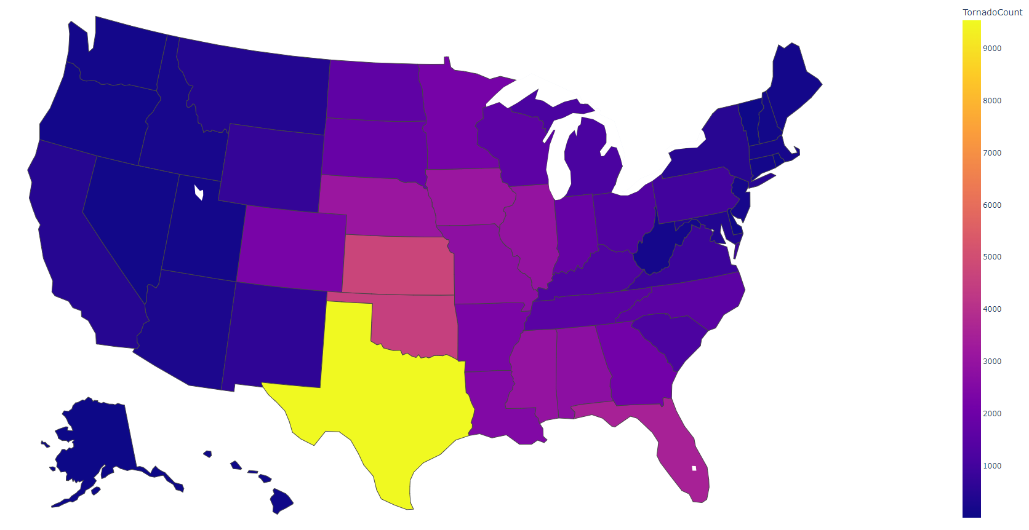

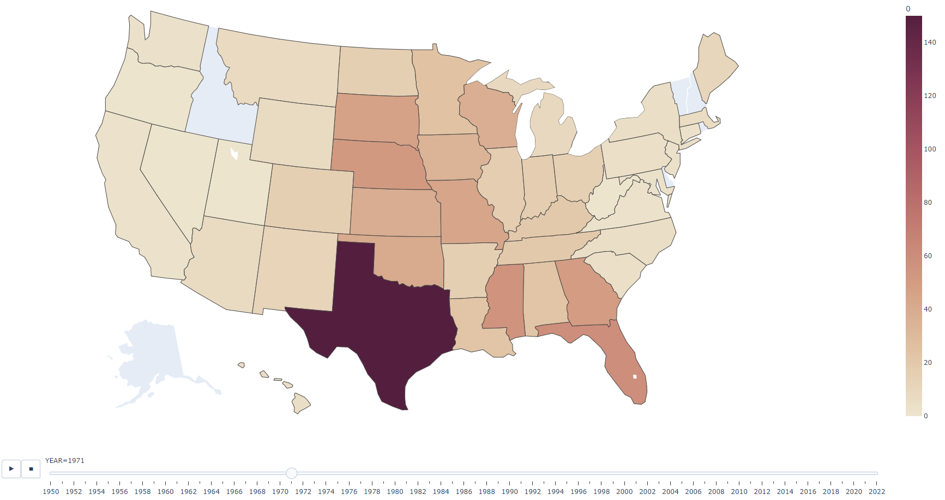

## Models

### Linear Model

To get a glimpse into what relationships were present within the variables present, we started by creating an OLS Regression test to see what popped up. As shown below, there were not many relationships that stood out when measuring everything vs. which state a tornado was likely to appear in. Predicting when an individual state will have their next tornado would be a billion dollar idea, so we knew that not much would come from an umbrella test such as this. We were surprised to see some variables appear as statistically significant within this test though. Either way, more testing needed to be done.

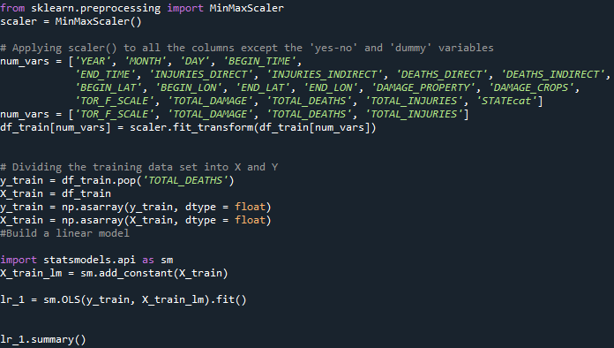

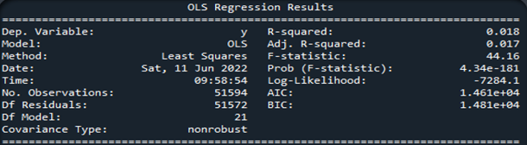

Next we tested all variables against F-Scale:

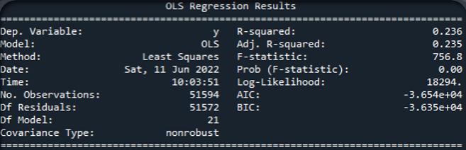

The R-Squared improved! Roughly 23% of F-Scale variance can be explained because of the variables in our dataset, and our F-Statistic allows us to place confidence in these particular results. However, these results allowed us to know that there were in-fact relationships present with our chosen variables. It became clear that if we wanted to improve our R-Squared value, the variables present within the test would need to be trimmed.

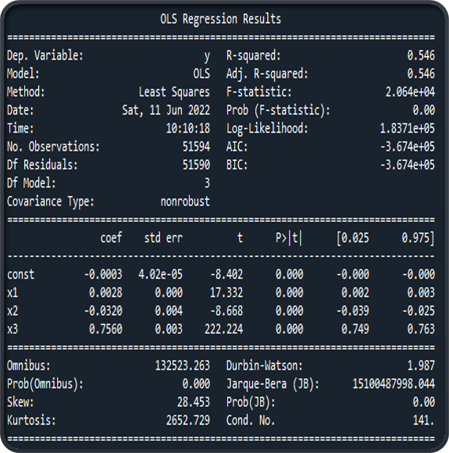

Above we can see the results of total damage, total injuries, and mean F-Scale vs. total deaths. Boasting our highest R-Squared value, this test was the result of measuring many different variables against the total deaths column to see what exactly created the best linear relationship for this tragic statistic. These three variables being tested against deaths make sense as the front-runners for causing the most variance; as the f-scale of a tornado goes up, the total damage follows suit, which in turn creates more injuries and those lead to death. This seems like a correlation of events that is easy to follow without a complicated linear relationship test saying so, however, seeing these factors stand out within a set of hard data was reassuring.

The linear modeling tests performed above provided a baseline for determining how predictable our data was. When including too many variables, the programs get bogged down by the potential relationships which prevents solid results from showing themselves. In order to create any meaningful information from this dataset we will have to be diligent with variable selection.

### LTSM Model

Next up on the modeling menu was an LTSM Model; long-short term memory. This test specializes in handling large sets of data, and seemed like a great fit for predicting the “big three” variables within our set: total damage, total, deaths, and f-scale. All models shown below:

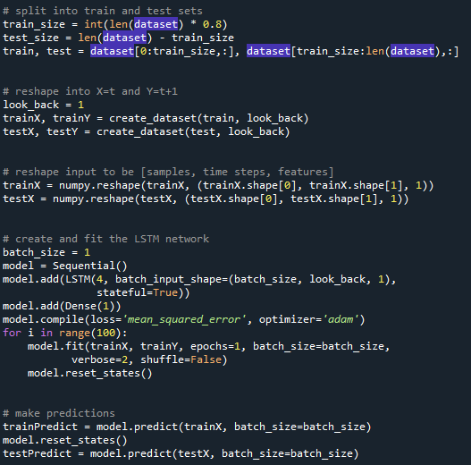

Total Damage:

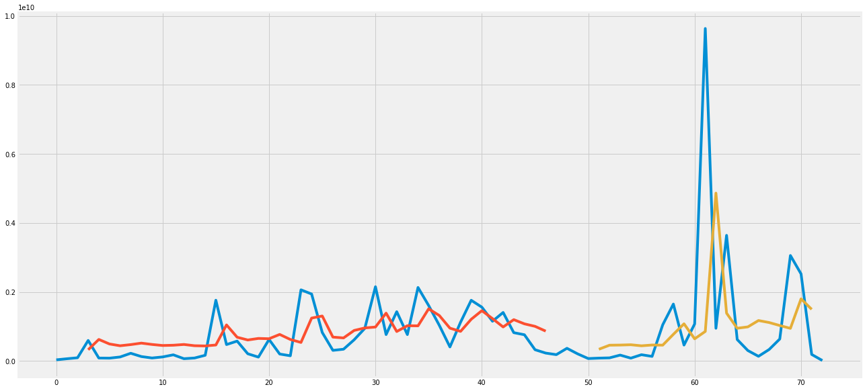

Total Deaths:

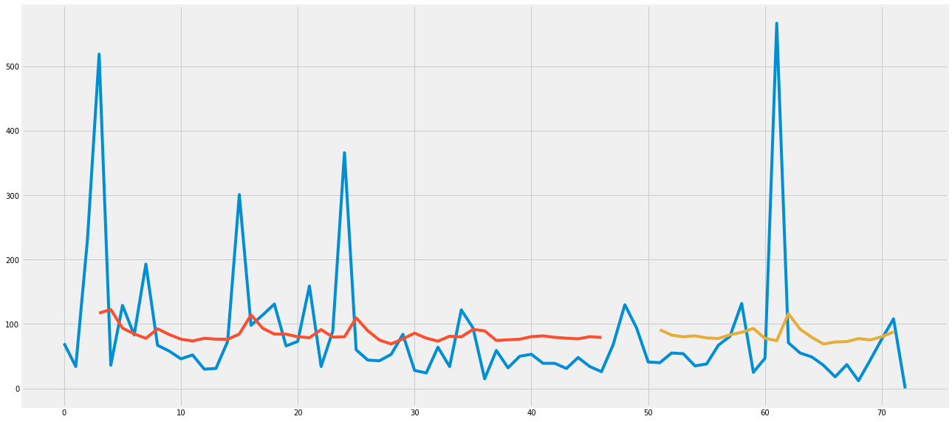

F-Scale:

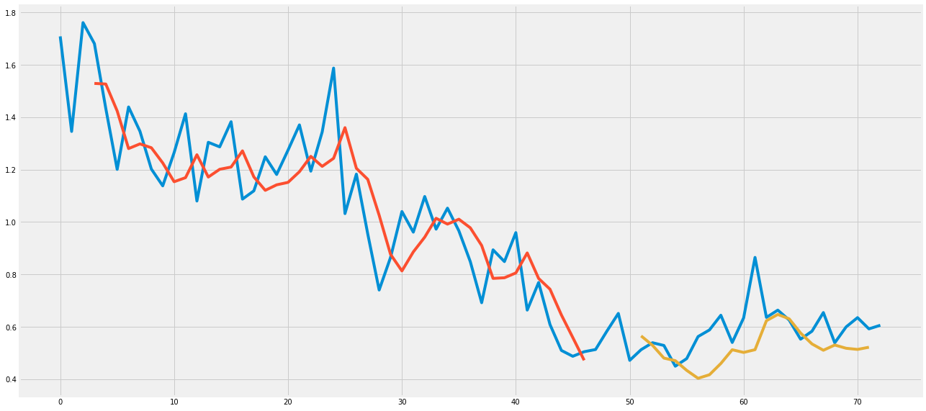

F-Scale Monthly:

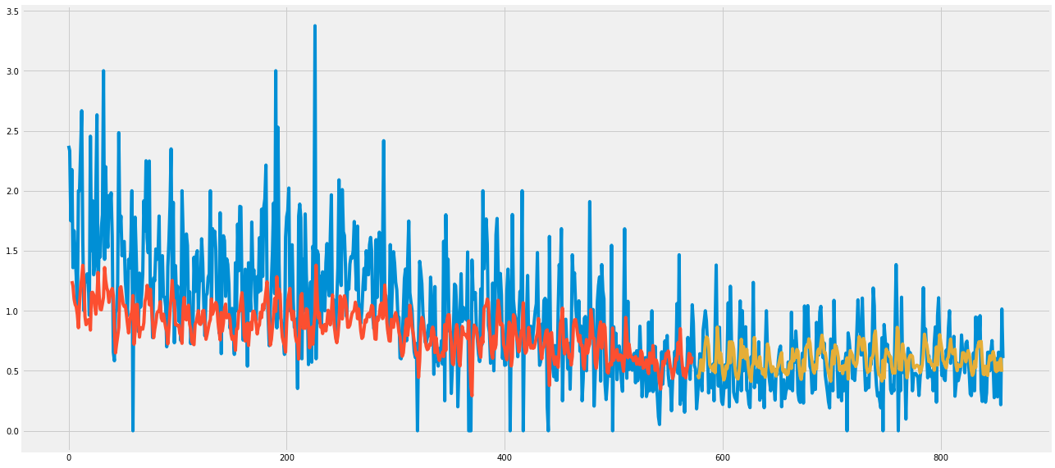

### Forecast Model

To create a forecast model the data first was checked to determine the inputs of the model and which model to use. There were two sets of data that models needed to be performed on in the context off this analysis. The first was a model on all of the United States counts put together. Through some tests and using general knowledge it was determined that seasonality would not be a factor in this particular analysis. This data was only given years meaning that months would not play a factor for this particular prediction. If months were put into consideration, I would have expected seasonality within the data, however due to the conditions an ARIMA forecast was chosen. Most of the data was already in decent format due to the previous visualizations but a few edits were made. The times were converted to datetime and set as index for the implementation in this model. This same process was also used in another created model that looked at each of the states individually.

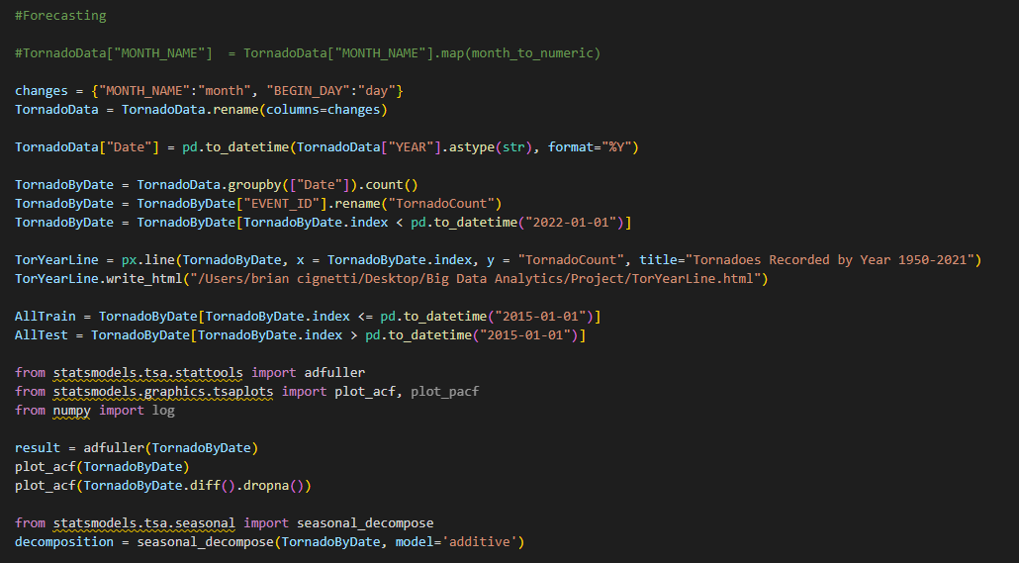

Now that the data was usable, it was split into a train and test set where 2015 was chosen as the cutoff giving six years to test. 2022 was left out of the model due to being incomplete in the full year count. Finally, the data for each set was plugged into the model, and with that model a prediction was created showing the trend and confidence intervals for the US in whole. This was accompanied by a loop that performed the same model for each of the states individually. The results for each state can be found in Appendix A

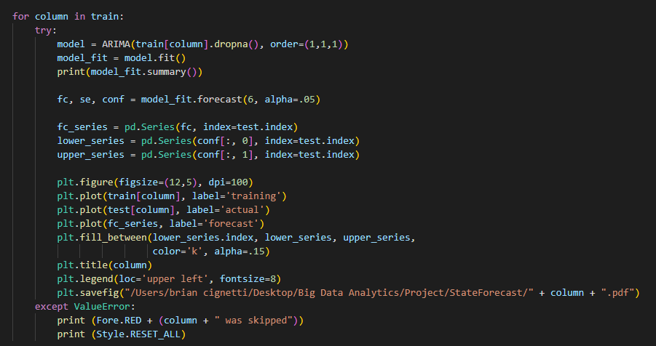

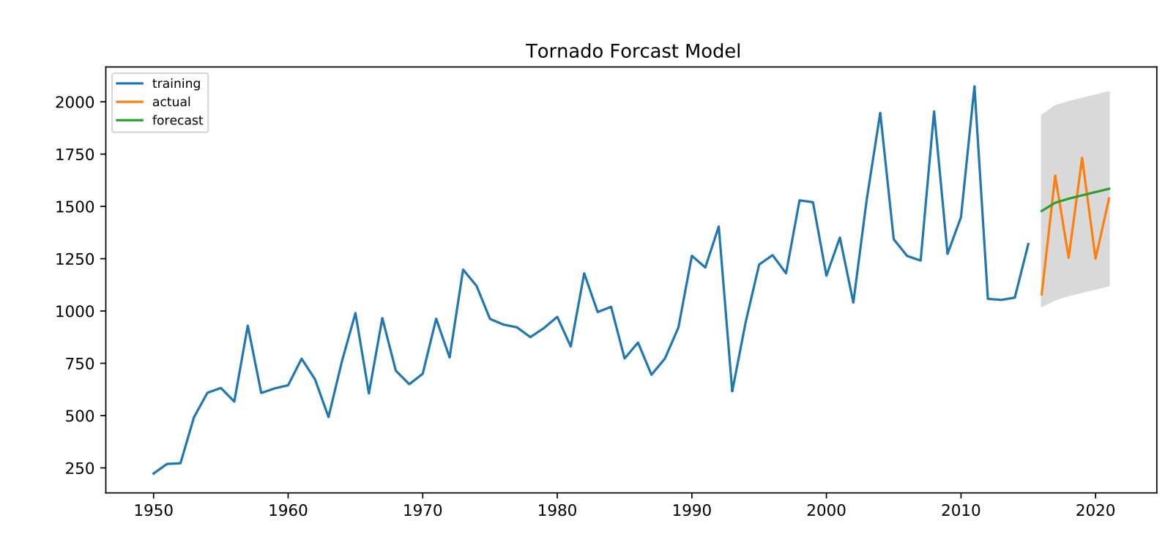

### Cluster Model

After looking at some of the forecasts for the United States and each state individually. There was a need to take an approach in questioning what exactly should tornado alley be? This led to a machine guided decision to be made using a K-means clustering algorithm to split the states into two groups, tornado alley vs not tornado alley. Due to the nature of a K-means cluster as much data as possible was included to compare all of the states together. To do this, multiple data frames were extracted and merged including tornadoes by year for each state, the number of F-scale tornadoes per state, deaths, injuries, and property damage.

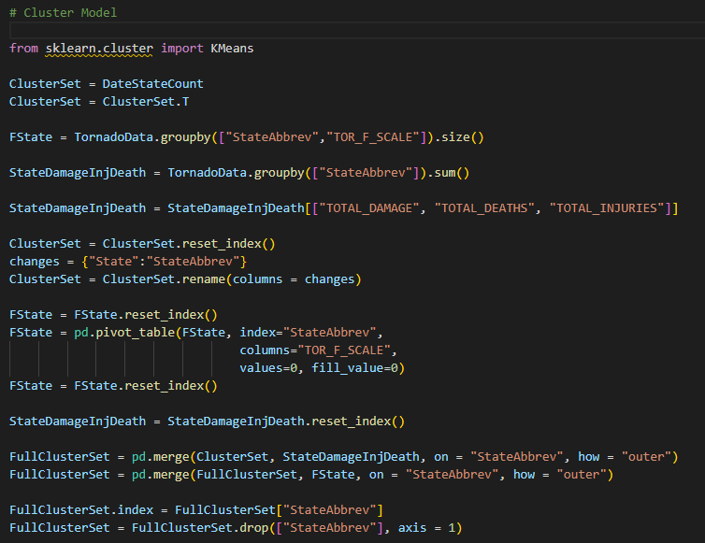

Now that the data was framed all of the data was thrown into the cluster algorithm and assigned a category based on the values. 2 clusters were chosen as a start to hopefully depict a tornado alley. After the model was completed and fit to clusters, the labels were assigned to the states. To visualize the results, the best course of action seemed to be another choropleth which showed the two groups which was put into another interactive html file thanks to Plotly.

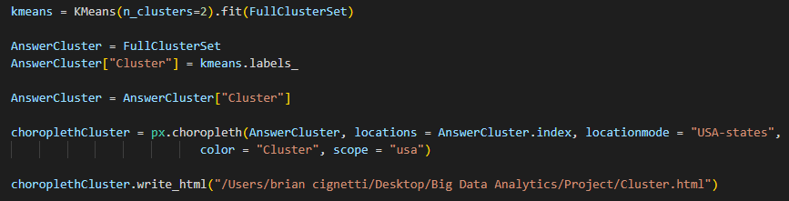

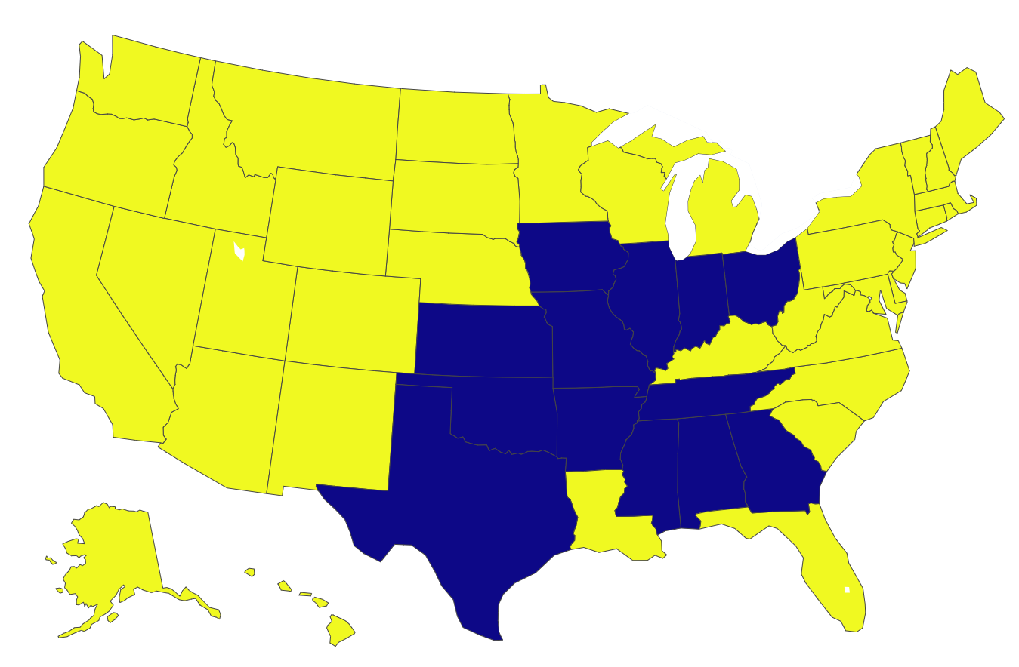

# Analysis of Results

## Visualizations

## Models

### Linear Model

Although this model was only meant to be a pulse-check on our data, it became clear that there is a reason as to why any meaningful weather predictions or measurements are performed with a super-computer. The amount of variables that shape the climate around us are unfathomable; we felt overwhelmed at times dealing with the ~20 variables within our dataset. The linear model was a wake up call that allowed us to be careful with how many variables we want to be throwing into our models, too few and we would be grooming the data unfairly, too many and we would end up with results that were meaningless.

### LTSM Model

Taking the results of the linear model into consideration, it made sense to visualize/predict the results of our most important variables within the dataset to see if any trends became clear. The total damage graph made clear that our total damage column was as difficult to predict as it likely was to gather the information to classify just how much one tornado caused. There’s no single team going around every state to mark down damages, so the findings for each tornado could possibly be gathered via different methods. Either way, our model held up decently against this tough variable, but we knew a better visualization was out there. Unfortunately, that better visualization would have to wait until after the total deaths model, because that too was difficult to predict. Although there are some instances of the predictive model following suit with the data, total deaths is not a statistic that is easily reproduceable for the sake of modeling.

Last but certainly not least, we tested/predicted F-Scale. This variable had much more of a predictable nature seeing as though its values were bound between 0-5. An interesting trend made itself known as we can see the mean values of F-Scales started out averaging around 1.4+ and then evened out below 1.0. We assume this is because in the early days of recording tornados, there was not much of a baseline to label a tornado’s size by; meaning that as the years go on, tornado size has more data to compare to and will therefore be labeled with better accuracy.

### Forecast Model

Looking at the results of some of the forecasting models, there appeared to be an uptick in the observed tornadoes from 1950-2021 as shown by the increasing green trendline in the forecast model. This can be attributed to the possibility that more tornadoes are occurring in the United States every year or the more likely option that more are being tracked. With an increase in the number of people recording tornado events more events are being recorded. With this one would expect more events to be labeled as observation skills become more refined.

However, looking away from the United States as a whole it was interesting to see what the trend was for some of the states considered “Tornado Alley”. Texas was the only state noted in the typical tornado alley to show an upward forecast line. Oklahoma and Kansas seemed to be forecasted downward possibly showing a shift in the convergence of winds that typically create the surplus in tornadoes. With that result there was an ambition to dig deeper and see what states could fit further into the category.

### Cluster Model

After looking through the results of the cluster model I was really surprised to see a result that intuitive on the first result. During the decision process, 13 states were selected to be in “Tornado Alley” as represented by the color blue. Of which the 3 original states of Texas, Oklahoma and Kansas are still represented but now there are other states included with a branch to the North through the rust belt and a line through the South. This result is interesting but expected based on the paths that tornadoes typically take during the summer months. During tornado season, bouts of weather typically begin in Texas and migrate either North or South based on the strength of cold winds from the North or warm winds from the South. The weather then migrates to the East hitting the states represented in blue.

Overall, this result is just a map, but the context is very important in this scenario. The typical states attributed to tornado alley make up a small portion of the states that are similar enough to tornado alley. With this we can suggest that although a lot of tornadoes occur in the states represented in the old adage, everyone in the blue states should be concerned that a devastating tornado can occur.

# Conclusions

Tornado Alley is an interesting premise as its cultural relevance remains ingrained in people all across America. This prevalence has led to representation in many forms of media but could be harmful as it creates a false sense of security. Although we have created models that can predict how many tornadoes could occur and many statistics associated with tornadoes, weather is always a very unpredictable occurrence.

Looking at some of the modeling and visualization techniques chosen throughout this examination of data, we encompassed a wide range of examining the topic. However, there will always be more ways to look at the data. Over time more data will be collected which can refine the models better, at that some of the models can be tuned even further. For instance, looking at tornadoes by state per month. But in the grand scheme of things, we have received the answer that we were looking for through our modeling. We uncovered that maybe the concept of tornado alley should be expanded thus raising awareness of more states to be prepared for tornadoes. In conclusion, it’s always better to be over-prepared than regret it later and with the weather, don’t leave your fate solely to past labels.

# Appendix A

